**Name: ALI ABID CHAUHDARY.**

**CLASS: BSCS-7B.**

**Registration No: 213292.**

**AP LAB 03.**

**Task 1:** Download Node.js from the official Node.js web site: [https://nodejs.org](https://nodejs.org/).

Downloaded and Installed.

**Task 2:** Once you have downloaded and installed Node.js on your computer, let's try to display "Hello World" in a web browser.

**Code:**

var http = require('http');

http.createServer(function(req,res){

res.writeHead(200,{'Content-type':'text/html'});

res.end('Hello World!');

}).listen(8080);

**Output:**



**Task 3:** Create a module that returns the current date and time. Save the code in a file called "myfirstmodule.js".

**Module Code:**

exports.myDateTime = function(){

return Date();

}

**Task 4:** Use the module "myfirstmodule" of date and time in a Node.js file.

**File Code:**

var http = require('http');

var dt = require('./myfirstmodule');

http.createServer(function(req,res){

res.writeHead(200,{'Content-type':'text/html'});

res.write("The date and time are currently:" + dt.myDateTime());

res.end();

}).listen(8080);

**Output:**



**Task 5:** The HTTP module can create an HTTP server that listens to server ports and gives a response back to the client. Use the createServer() method to create an HTTP server.

**CODE:**

var http = require('http');

http.createServer(function(req,res){

res.writeHead(200,{'Content-type':'text/html'});

res.write(req.url);

res.end();

}).listen(8080);

**Task 6:** Add an HTTP Header

**Output and added header:**

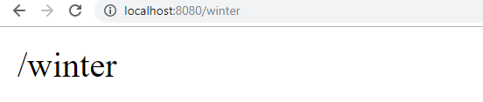

**Node.js as a File Server:**

**Task 7:** Create a Node.js file that reads the HTML file, and return the content.

**File Code:**

<html>

<body>

<h1> My header </h1>

<p> File system look and Feel</p>

</body>

</html>

JS File CODE:

var http = require('http');

var fs = require('fs');

http.createServer(function (req, res) {

fs.readFile('demo.html', function(err, data) {

res.writeHead(200, {'Content-Type': 'text/html'});

res.write(data);

res.end();

});

}).listen(8080);

**Output:**

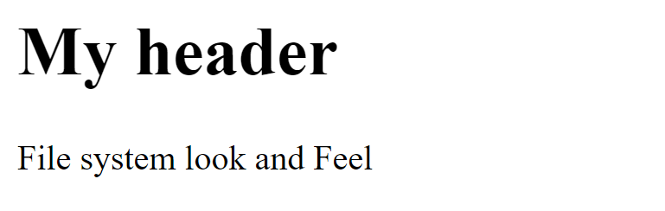

**Task 8:** Create a new file using

* appendFile() method:

**CODE:**

var fs = require('fs');

fs.appendFile('newfile.txt','Node file system look and feel.',function(err){

if(err)

{

throw err;

}

console.log('File appended');

});

**Output:**

**1 Command Prompt:**



**2 File Output:**

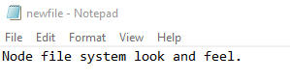

* open() method

**CODE:**

var fs = require('fs');

fs.open('newfile2.txt', 'w', function (err, file) {

if (err) throw err;

console.log('File Opened');

});

**Output:**



* writeFile() method

**Code:**

var fs = require('fs');

fs.writeFile('newfile3.txt', 'Writting on the new file.', function (err) {

if (err) throw err;

console.log('File written');

});

**OUTPUT:**

**1.**



**2.**

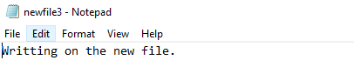

**Task 9:** Append "This is my text." to the end of the file "mynewfile1.txt".  
**Code:**

var fs = require('fs');

fs.appendFile('newfile.txt', 'New content appened.', function (err) {

if (err) throw err;

console.log('Append successful!');

});

**Output:**

**1.**



**2.**



**Task 10:** Replace the content of the file "mynewfile3.txt".

It can be Done through write file method.

**CODE:**

var fs = require('fs');

fs.writeFile('newfile3.txt', 'Replacing Content', function (err) {

if (err) throw err;

console.log('Content Replaced!');

});

**OUTPUT:**

**1.**



**2.**

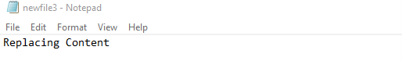

**Task11:** Delete "mynewfile2.txt".

**Code:**

var fs = require('fs');

fs.unlink('newfile2.txt', function (err) {

if (err) throw err;

console.log('File deleted!');

});

**Output:**



**Task 12:** Rename "mynewfile1.txt" to "myrenamedfile.txt".

Code:

var fs = require('fs');

fs.rename('myfile.txt',' renamedfile.txt', function (err) {

if (err) throw err;

console.log('File Renamed!');

});

**Output:**

